FOREGROUND MASKING RESEARCH

Toy Objects Results: SEP versus MTObjects
Matched 182-galaxy comparison using standard injected toys
Prepared: 24 August 2026
Status: Results, interpretation and recommendation
Executive conclusion: SEP recovered more toy pixels and achieved higher F1 at essentially the same mean masked area. MTObjects had a nearly identical whole-toy detection rate and a lower extreme masked-area tail. Prefer SEP for recovery, with a per-image area guardrail and morphology review; use MTObjects as the conservative fallback for high-risk galaxies.

1. Comparison basis
All direct conclusions use the matched 182-galaxy standard-toy comparison. Each algorithm received the same science image, six toys, placement seed 202608299 and truth mask. Both batches succeeded for all 182 galaxies.

2. Population results
Metric | SEP | MTObjects | SEP - MTO
Mean masked image area | 8.82% | 8.89% | -0.07 pp
Median masked image area | 8.36% | 8.77% | -0.41 pp
Mean toy-pixel recall | 70.57% | 62.42% | +8.15 pp
Median toy-pixel recall | 82.88% | 63.82% | +19.06 pp
Mean toy detection rate | 68.68% | 68.96% | -0.27 pp
Mean per-toy recall | 68.86% | 67.78% | +1.08 pp
Mean toy-associated precision | 0.700% | 0.560% | +0.140 pp
Mean toy F1 | 1.381% | 1.107% | +0.274 pp
Mean non-toy mask fraction | 8.77% | 8.85% | -0.07 pp

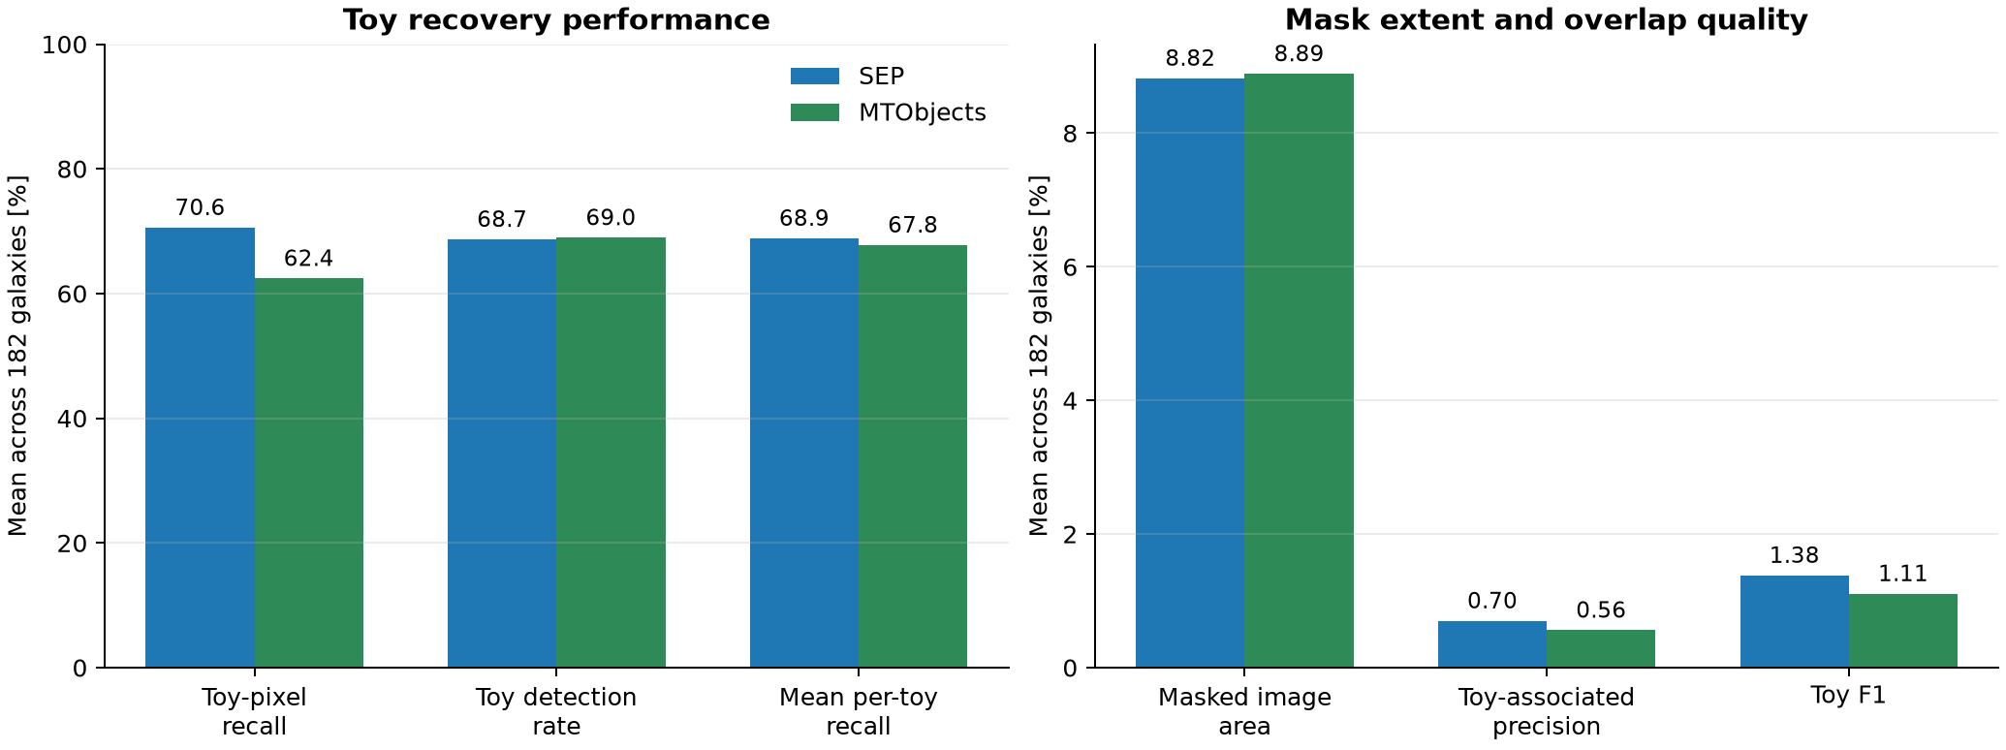
Figure 1. Mean recovery, mask extent and overlap-quality metrics across 182 matched galaxies.

3. Paired galaxy-level outcomes
Paired outcome | Galaxies | Interpretation
SEP higher toy-pixel recall | 121 / 182 | SEP advantage in two-thirds of the sample.
MTObjects higher toy-pixel recall | 57 / 182 | Four exact ties.
SEP masks less total area | 121 / 182 | SEP is not systematically more aggressive in the typical case.
MTObjects masks less total area | 61 / 182 | No ties.
SEP higher toy F1 | 134 / 182 | Better recovery/precision balance more often.
MTObjects higher toy F1 | 47 / 182 | One exact tie.

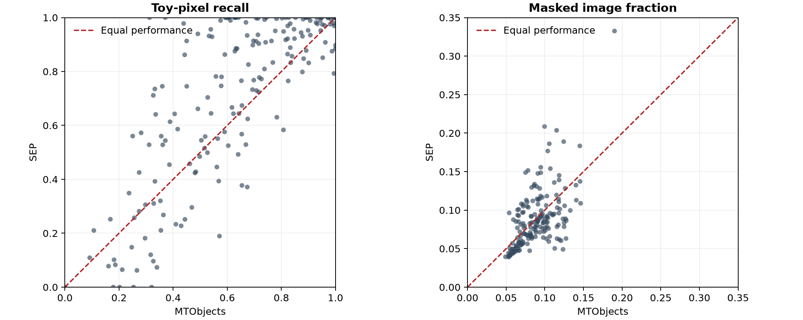
Figure 2. Each point is one galaxy; the dashed diagonal marks equal performance.

4. Distribution and outlier behaviour
Masked-area statistic | SEP | MTObjects
10th percentile | 4.91% | 6.01%
25th percentile | 6.30% | 6.90%
Median | 8.36% | 8.77%
75th percentile | 10.35% | 10.27%
90th percentile | 13.23% | 11.94%
95th percentile | 15.14% | 12.68%
Maximum | 33.26% | 19.02%

Average mask areas are almost identical, but SEP has a heavier upper tail. The final sample includes galaxies unlike the 40 calibration cases, so the tuning-era 15% cap does not ensure every production image remains below 15%. SEP outputs above the threshold require automatic flagging and review.

5. Calibration and generalisation
Selected-candidate metric | SEP (fold 4) | MTObjects (fold 3)
Held-out mean toy recall | 40.14% | 52.55%
Held-out toy detection | 40.00% | 55.00%
Held-out mean masked fraction | 6.20% | 8.82%
All-40 mean toy recall | 45.38% | 50.70%
All-40 toy detection | 45.42% | 53.33%
All-40 mean masked fraction | 5.71% | 9.07%

These optimisation figures support reproducibility, not paired comparison: tuning used different injection seeds and incremental-mask scoring. The matched 182-galaxy results are the appropriate head-to-head evidence.

6. Visual comparison: NGC3627
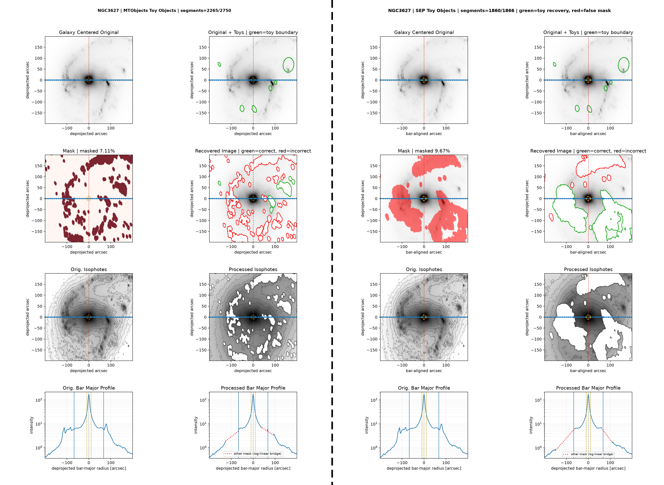
Figure 3. NGC3627 matched diagnostic: MTObjects left, SEP right; dashed black divider between methods.
The paired layout exposes the trade-off directly: compare identical toy boundaries, total mask extent, recovery outlines, isophote preservation and profile bridges before accepting a method for a galaxy.

7. Interpretation
- SEP has stronger average toy-pixel recovery: +8.15 percentage points, with a larger median advantage.
- Whole-toy detection is effectively tied. SEP tends to recover more of each toy rather than detect more toys.
- Mean masking is effectively tied and SEP masks less area in 121 galaxies; however, SEP has the more severe high-mask outliers.
- Toy-associated precision below 1% does not mean all other masking is wrong: real pre-existing foreground objects are absent from the synthetic truth. It does show that toy overlap alone cannot measure scientific selectivity.
- Toy Objects test synthetic recovery, not accuracy for real foreground objects without labelled real-object validation.

8. Recommendation

Primary recommendation
Use SEP as the preferred Toy Objects configuration when maximal recovery is the main requirement: it provides higher recall and F1 without increasing mean masked area.

Required SEP safeguards
- Flag masked area above 15%; treat above 20% as automatic manual review.
- Review large coherent components resembling arms, rings, bars or extended galaxy structure.
- Retain the eight-panel diagnostic and inspect processed isophotes and bar-major profiles.
- Record both total mask area and target recovery; neither is sufficient alone.

When to prefer MTObjects
Use MTObjects when SEP enters the high-mask tail, coherent morphology appears threatened, or lower worst-case mask extent is more important than maximum pixel recall.

9. Next improvements
- Repeat cross-validation with identical toy placements and seeds for both algorithms.
- Add morphology-protection terms for azimuthal span, annular coherence and low-frequency galaxy structure.
- Use a constrained Pareto objective over recovery, masked area and profile/isophote preservation.
- Create a manually labelled real-foreground subset for real-object recall and false-mask assessment.
- Test a guarded hybrid: SEP first, with MTObjects fallback for SEP high-mask or morphology-risk cases.

10. Outputs and sources
Statistical workbook: D:\Dropbox\Public Documents\UCLAN\MSc Research\Remove foreground objects\documentation\Toy Objects SEP vs MTObjects Statistical Comparison.xlsx
Visual comparison: D:\Dropbox\Public Documents\UCLAN\MSc Research\Remove foreground objects\Toy Objects comparison\20260821_104129
SEP optimisation: D:\Dropbox\Public Documents\UCLAN\MSc Research\Remove foreground objects\sep toy cross validation\20260817_161404
MTObjects optimisation: D:\Dropbox\Public Documents\UCLAN\MSc Research\Remove foreground objects\mtobjects toy recovery followup\20260816_063455

